**Healing With Dolphins**

By Anne Wister, LMT, CST-D

## Introduction

Working with dolphins has been one of the most amazing experiences of my life. They are so open and loving, unconditionally loving. They take care of each other, raise their young communally, hunt in groups, work together, play together and live together, sharing all of their experiences.

They also share with humans. There has been a lot of research with dolphins, but getting to work with them first hand or even swim with them, is an extraordinary experience.

## The Beginning of the Journey

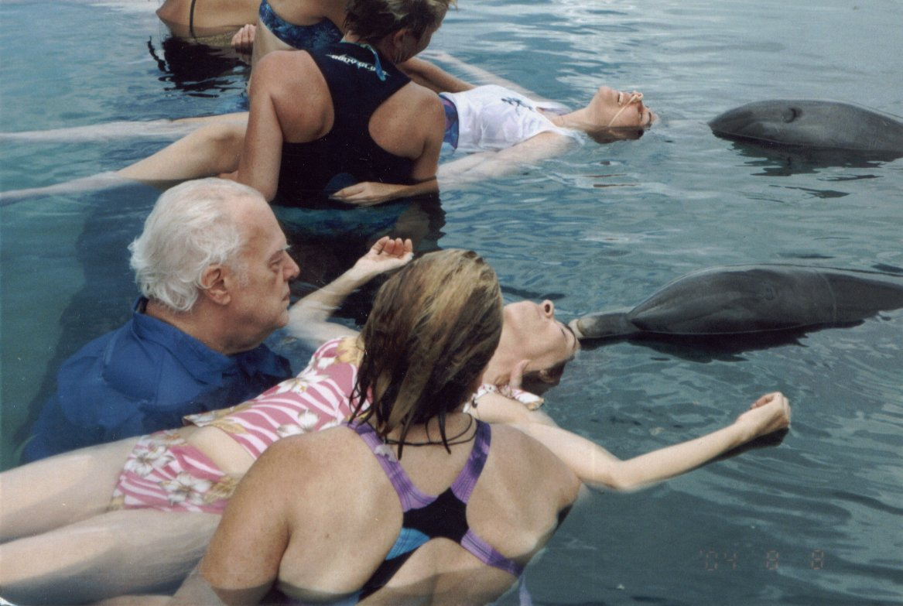My adventure started at a conference in West Palm at the Upledger Institute, where I was studying craniosacral therapy with Dr John Upledger. Dr John had been working with the dolphins for years and you can read about some of his adventures at [www.upledger.com](https://www.upledger.com/about/john-upledger). I talked with some of the teachers there at the institute and won a raffle ticket for a dolphin assisted therapy class.

At the facility, I signed up for a dolphin swim the day before the class started. I was so excited I couldn’t wait! We took a boat ride to the lagoon where the dolphins live in semi-captivity. The lagoon is enclosed with a wooden floating dock. The dolphins were swimming freely in the large, open area. There were several enclosures where the dolphins interacted with humans. We got our instructions and six of us slipped into the water with flippers and masks and started swimming. There were two dolphins with us and as I swam away from the dock, Kaylat came up right beside me. I put my hand on her, right behind her eye, and we dove. I just kicked my feet and somehow, magically, she pulled me along as we swam together. She would bring me up to breathe and then we would dive down again. We were eye to eye and the feeling was like flying or just leaving my body all together.

I was out of breath in about 3 minutes so I stopped on the surface to catch my breath as she went off to swim with someone else. The dolphins were totally tuned into each person, their strength or lack of it, their comfort in the water, their fear or excitement. One man arrived at the dock with two canes and one of the dolphins came slowly up to him, let him hold on, and gently and slowly lead him around on the surface. I was ready for more contact so I started swimming and immediately Kayla came up and as I dove and reached out and lightly placed my hand on that special spot, we were connected and took off.

We did some behaviors in a circle, splashing and “talking” and playing which was entertaining but nothing like the feeling of becoming one with the grace and ease of their movement through the water. It was an exhilarating and freeing experience. We were all elated as we climbed out of the water and sat on the dock. Then we got to observe the second group as they swam and interacted with the dolphins.

I left that day a changed woman. The opening and the sense of awareness and communion was truly amazing. It was like sailing offshore with only the water on the horizon in a stiff breeze or standing at the top of a mountain I had just climbed with the view spreading out before me and the wind on my face. Only better! I watched the female dolphins swim around the enclosure by the dock as we waited for the boat to take us back to town, feeling so much gratitude and appreciation, and being full of love and joy.

## Dolphin-Assisted CranioSacral Therapy

And that was only the beginning! The next morning, we met in our quaint hotel room/classroom and had introductions and explanations. We took the boat over to the lagoon and divided into groups of 12. We walked past the parrots and down to another enclosure (floating docks in a square) where there was a cement platform 3 feet under the water. At the edge of the platform, the water level drops to 12 feet and the dolphins have underwater access from their lagoon. The trainers brought the two dolphins in, and as we walked down the ramp and got into the water, we could feel the excitement and anticipation from the dolphins.

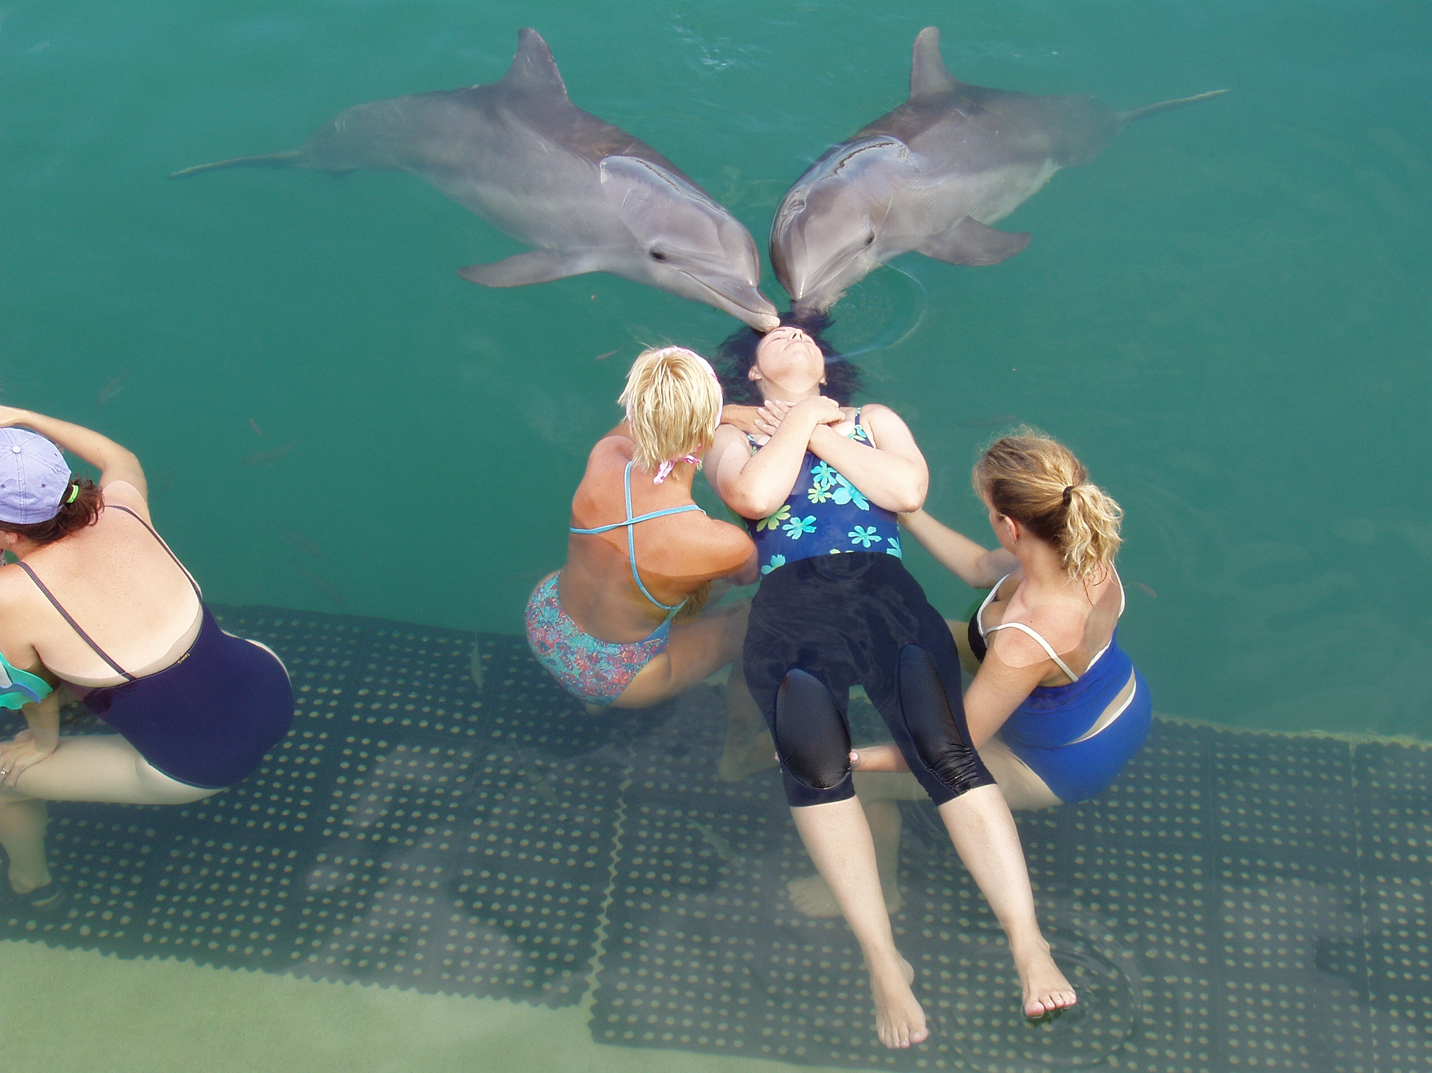We spread out on the platform in 4 groups of 3 and one of us lay down in the water, floating on our backs. The other 2 therapists rested their hands on the “client’ in a place they were drawn to, and we settled in, beginning to treat with craniosacral therapy. The presence of the dolphins so nearby electrified the water and heightened all our senses. The dolphins came up to us and Kaylat put her back up against mine. I felt like she was working through me, sending energy into the client. My whole body came alive as I caught my breath. They are BIG animals and when they lay up against you, you definitely feel them! After a few minutes, she backed up and brought her rostrum (long snout) to the client’s shoulder. They use their melon (forehead area) to send sonar vibrations for locating fish and landmarks, and it felt like they were sending this echolocation into the client as a way of sending healing energy to the area of pain or dysfunction. We found that the dolphins went right to the areas of complaint.

When it was my turn to be the client, I lay in the water and closed my eyes, relaxing as much as I could with the wild anticipation pounding in my heart. In 1988, I was in a major car accident where my vehicle was struck by a Mac truck going 40 mph. I sustained a total body whiplash and have been treated by a chiropractor ever since. My neck and low back have never been the same. Kayla came up to me, went underneath my body with hers at my tailbone and lifted me out of the water about 18 inches. She proceeded to move from my tailbone to my neck, slowly rolling my entire spine from bottom to top. It was an amazing feeling and I was totally relaxed and flexible as my back arched up into a full back bend. She let me down gently, rolling softly away from my neck and coming around to my left hip, where she pushed in lightly with her rostrum. It felt like a mild adjustment and I felt the electricity running up my spine.

When I got out of the water, I remarked, “I remember THIS spine! The last time I felt this way I was 14 years old!”

## Remarkable Cases

One of the women in our class had a lymphatic condition that had caused her skin to turn purple and bumpy. She was an athlete and an experienced swimmer/diver. She dove with the dolphins and swam for many minutes with them in the free swim encounter. At the end, the large male dolphin seemed agitated and kept coming to hover around her, disobeying the trainers attempts to bring the dolphins to the dock for directions. At the last minute, he disappeared and swam away, only to appear the next second, coming at her fast. He rammed into her right inguinal lymph node, hitting her HARD between her right shoulder and chest. She gasped and we were all startled. The trainer was very displeased and wanted her to go to the hospital. After the shock, she seemed to be fine, and during the week many things came up for her. The condition, which had been treated for a long time by many medical doctors, completely cleared up in the next few months and she is free and clear of it to this day.

We had three more mornings with the dolphins and the miraculous experiences kept happening for all of us. The gentleman who came to the dock with two canes for support walked away on day 4 on his own with good balance and an easy gait. My hips freed up and I had no pain in my neck for the first time in years.

On the last day, we had two younger male dolphins. The trainer kept them away from direct contact with us, about 10 feet away. At first, we were upset and angry, feeling we would not get the healing energy we had come to crave and expect from our water time. But as we lay down in the water, we could still feel their energy and presence surrounding us, like the warm rays of the sun, soothing and filling us, helping our bodies heal, our minds relax and our hearts fill with peace and joy. At one point in the session, both dolphins left the enclosure (not a trainer sanctioned activity) and took a full spin around the lagoon. It seemed that they were eliciting the help of the entire pod of 15 dolphins and when they came back, we felt the community as a whole, the cooperation, the unconditional love, the caring and communion of the group consciousness. They were sharing with us how THEY live, love and play in harmony and cooperation. They let us into their world and showed us how it can be, if we choose it. When we got out of the water that day, we were all profoundly quiet, or in gentle tears from the beauty and privilege of such an experience. And we hadn’t even had any physical contact!

The experiences and stories are many, especially the children and how the dolphins work so carefully and gently with them. And the bald man, who was afraid of the water but had always wanted to be with the dolphins. They took one look at his bald head and looked at us as if to say, “We know what THAT is!” and bonked his bald head, dunking him under water like they were playing with a ball. He LOVED it and is no longer afraid to get his head wet!

## Lessons from the Dolphins

The dolphins are so giving and considerate. They have communicated to us that they are pleased to be of service to the humans. They want to share what they know, they want to help us. I see them as missionaries, coming to help us in our time of need. We need to protect them, our oceans and our shores. They have so much to teach us and we need to pay attention and learn. The whales and dolphins are conscious, sentient beings with more wisdom and experience than we give them credit for. I have realized that from my time with them. It would be a real tragedy to lose this amazing species and all their wisdom. If you get the chance to swim with dolphins, or get near them in any way, take it. Take it with humility and care, respect them and be open and you may receive a wonderful gift as I have.

## Anne Wister CST, LMTAbout the Author

Anne Wister is a Certified Advanced Craniosacral Therapist working with Integrative Intentions and the Upledger Institute and has a private practice in Gainesville and Clearwater, Florida.